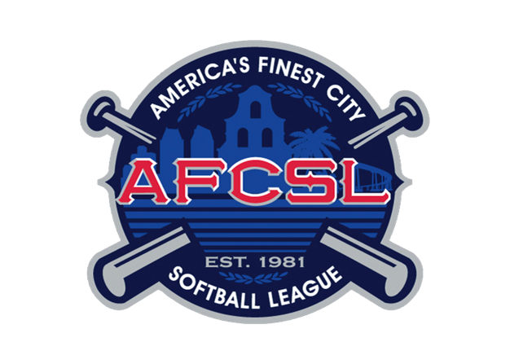
2021 Hall of Fame Nomination Form

Name of Nominee:
(If the Nominee is living, please complete the appropriate information below)
City:
State:
Telephone Number:
Years in AFCSL:
Email:

League Accomplishments:

Other Qualifications:

We encourage you to submit a photo with your nomination. This photo will become the property of the AFCSL Hall of Fame.

Nomination Submitted by:
Telephone Number:
Email:

Please email completed form to: secretary@afcsl.org

